|  |  |
| --- | --- |
| Simulation Report |  |

# Project Name: AC to DC Motor Drive Date: 04.1.19



# Project Members

|  |  |  |  |
| --- | --- | --- | --- |
| **BURAK KEMAL KARA** |  | **MERT YAŞAR AYDIN** | **CEM DUMAN** |

Table of Contents

1. Introduction 3

2. Topology Selection 3

a. Single Phase Thyristor Rectifier 3

b. Diode Rectifier and Buck Converter 5

c. Final Decision 6

3. Component Selection 7

4. Thoughts about Bonus 9

a. Industrial Design Bonus 9

b. Four-Quadrant Bonus 9

5. Conclusion 9

# Introduction

In this report, we will discuss why we choose the rectifier plus buck converter topology to others. While we are trying to explain the choice of us, we provide some visual and simulation data to prove our decision is correct in terms of our requirements. For that purpose, firstly, we will introduce some alternative topologies with their specifications like cost, performance, simplicity and flexibility for addition of another systems. Secondly, we will introduce our requirements in a simple manner. Then, we will explain the deep details of our topology and share the simulation results in this report. Since the component selection will be also mentioned in this report, The results that we provide will include for all components in our designed converter.

# Topology Selection

As M.P.W.U we discuss on three topology to achieve our goal. Each topology has their own benefits but, we will decide to use one of them. Since it is hard to see their advantages and disadvantages at a glance, in this part we will analyze them individually.

## Single Phase Thyristor Rectifier

Single Phase Thyristor configuration is a commonly used topology for rectifing AC signals.Although this configuration has many advantages,it also has disadvantages either.In order to analyse this topology,a simple circuit analysis is done at Simulink/Matlab.

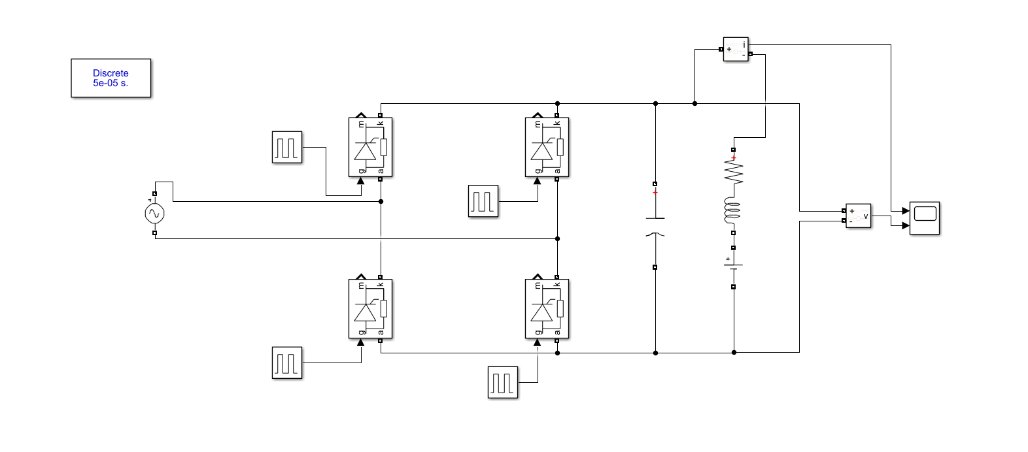

Figure 1 Schematic of Single Phase Controlled Rectifier

DC motor can be represented as a series resistance R(0.8Ω) ,series inductance L(12.5mH) which are the armature resistance and inductance values and DC voltage source to represent back EMF(considered as 100V) as in the figure above.

One of the main problems of this topology is that the capacitor that is used for making the ripple of the output voltage($V_{p-p}$) smaller ,needs to be too large.For example,according to simulations,i.e. figure 2,the neccesary capacitor to make output ripple as small as in the figure 2 is 100mF which is a very large capacitor.Anoher problem is that,although the pulse generators seem simple at figure 1,they are not in real life.Additional pulse generator circuits needs to add to system in order to maket his topology operate properly.Also,synchronizing these pulse generators according to proper firing angles(α) is a serious problem.

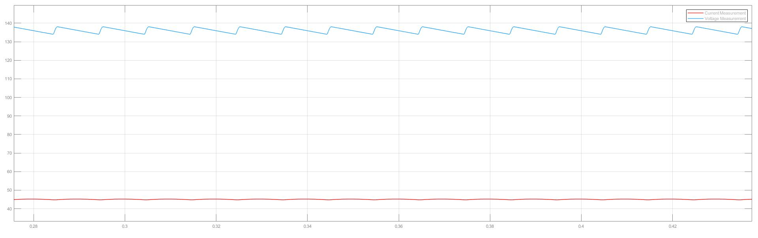

Figure 2:Voltage and Current Waveforms of Single Phase Thristor Rectifier

As all engineering applications,this topology has advantages and disadvantages.

-The Advantages of this topology;

1. It’s four quadrant operation is much simpler than diode rectifier-buck converter configuration.
2. Cheaper
3. Easier to achieve simplicity bonus

-The Disadvantages of this topology;

1. Aranging and synchronizing the firing angle of the gate signal
2. Gate driving circuit is hard to implement
3. The capacitor at the load side needs to be larger compared to Diode Rectifier+Buck Converter Topology

## Diode Rectifier and Buck Converter

At this topology we first rectify AC signal to very low ripple dc signal. Since we cant control voltage value with diode rectifier, Buck converter gives an opportunity to change voltage level of output. We don’t need to use Inductor at buck converter since dc motor is a huge inductor.Simulation of this topology done on Simulink. Schematic is shown at Figure 3.

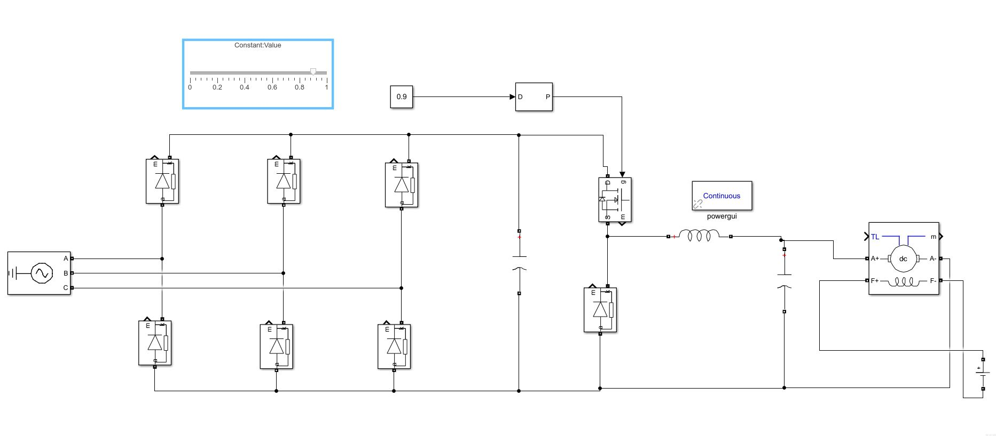

Figure 3 Schematic of Diode Rectifier and Buck Converter

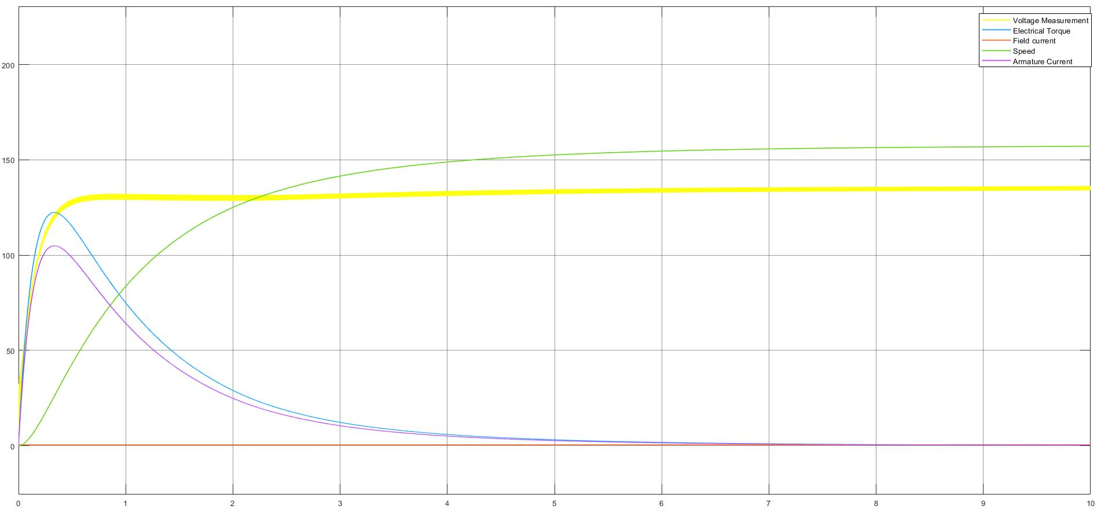

Figure 4 Motor and Input Voltage Graph

At Figure 4 we can Motor and Input Voltage. Speed of motor is given in rad/s. It is around 160 rad/s. Rpm value is 1527. Also Note that when motor is not moved yet, There is huge current passing from Motor. We will also implement a soft start system by feedback.

-The Advantages of this topology;

1. Easy to construct
2. Easier control system( one actuator signal) compared to thyristor topology
3. Low voltage ripple

-The Disadvantages of this topology;

1. Hard to use implement four quadrant operation
2. Buck converter needs an inductor to work

## Final Decision

As M.P.W.U. ,we decided not to use Thyristor topology because when we compare two topology ,the disadvantages for Thyristor topology preponderated. Above all, diode rectifier with buck converter give us easy construction and flexibility. Also there is bonus question in this project we can achieve them with Diode rectifier easier.

# Component Selection

We have simulated the design and obtained some waveforms to decide on the components we will choose. The simulations are done under the real motor parameters and required voltage levels from us.As you can see from the figures diode peak voltage is nearly 200V and it will be enough to select diodes with Vrrm=250V. And, from the other figure, diode peak current is nearly 150 A. However, this case is worst scenario case. In other words it is at the starting moments of the motor which has very current at starting. we will implement a controller for it to reduce that current. However even if we don’t implement a controller we may overcome this problem with another ways therefore, current value of the diodes are determined later. And our mosfet should bear nearly 150 A values. And, since we are operating at 500 Hz frequency for the mosfet these also should be considered.

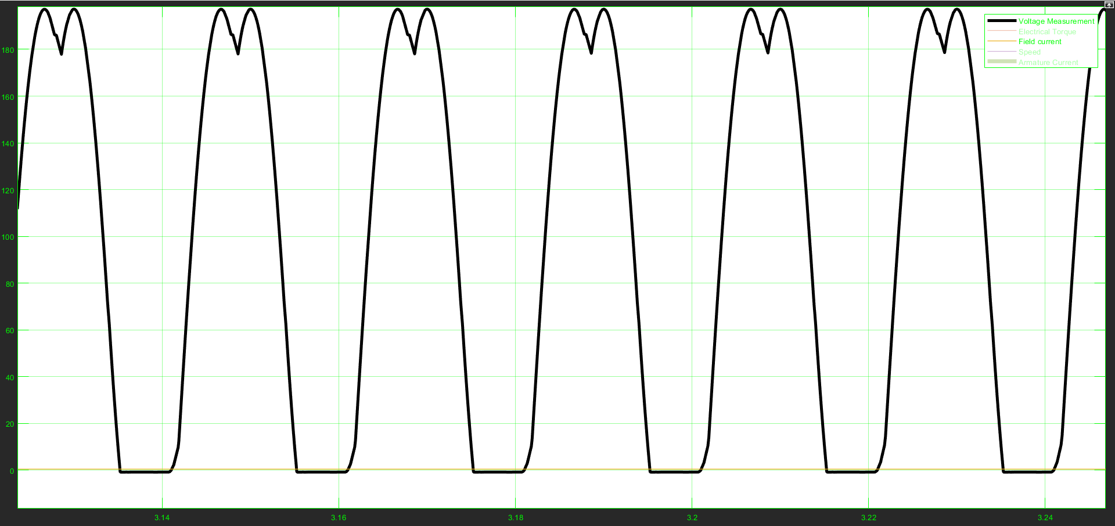

Figure 5: simulation of diode Reverse repetitive peak voltage.

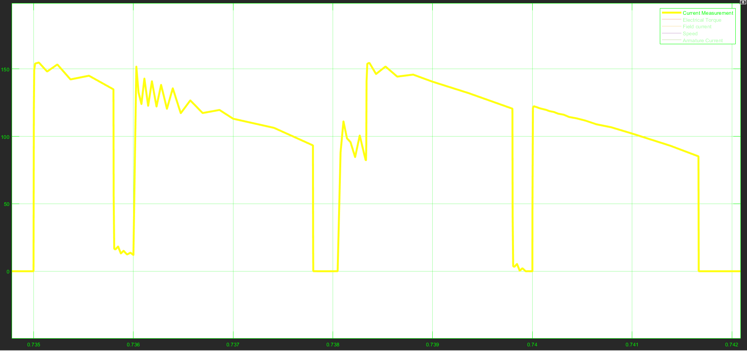

Figure 6: simulation of diode currents.

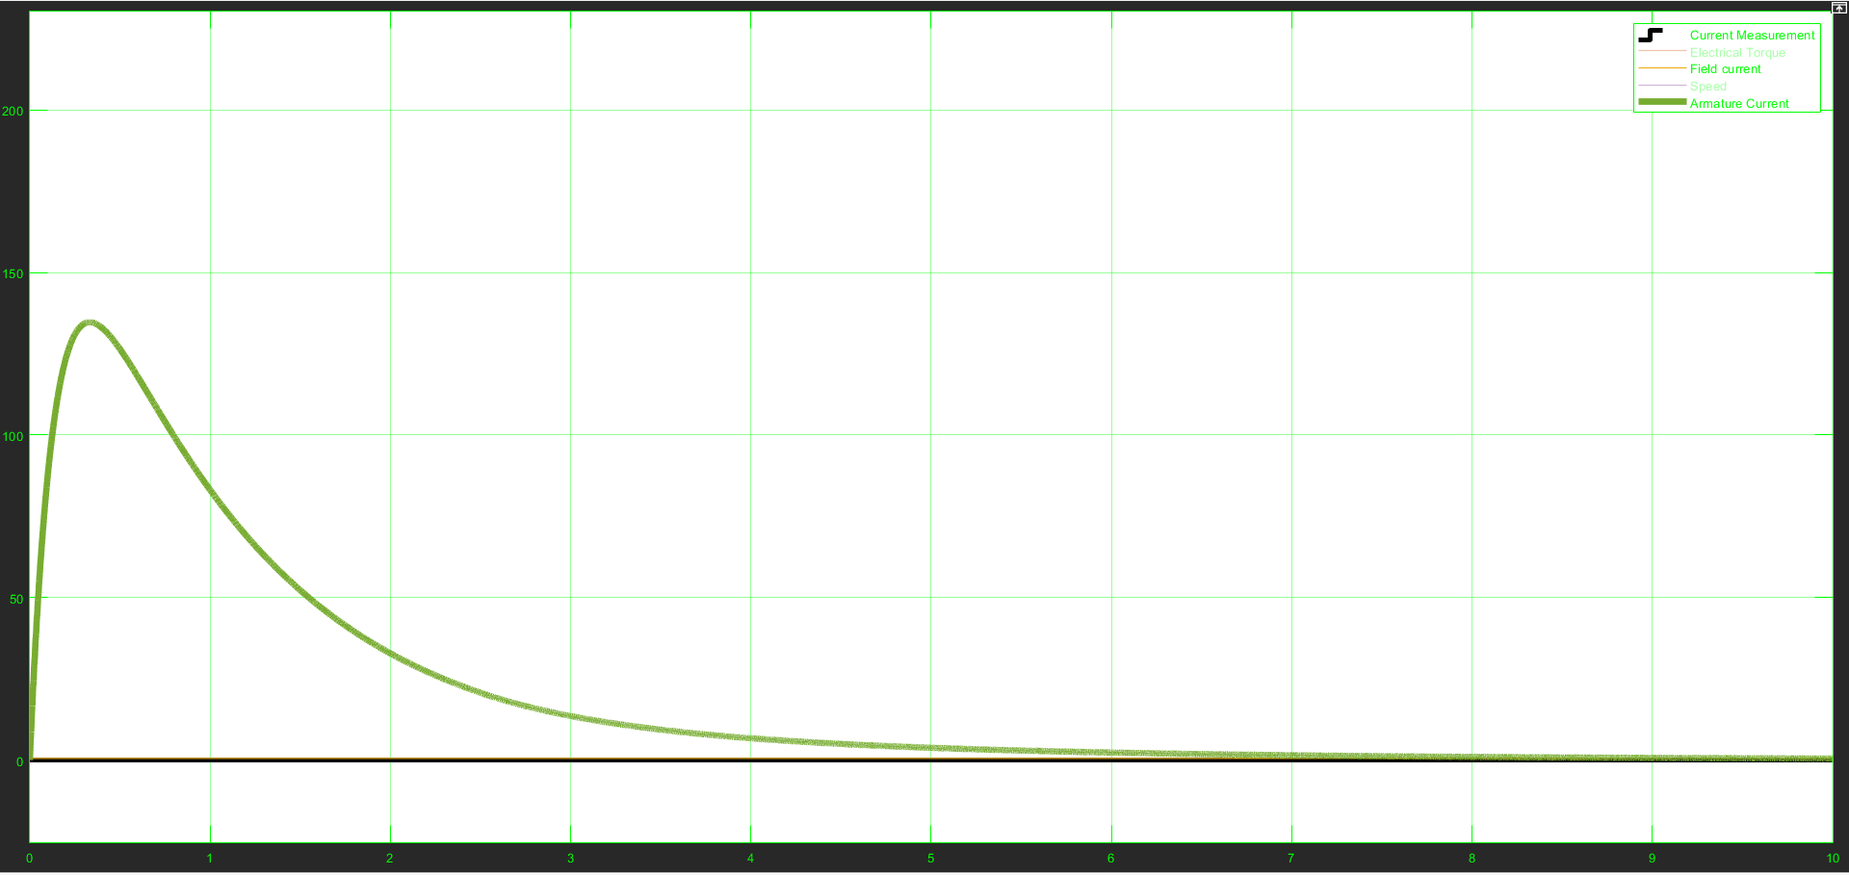

Figure 7: armature current half of which pass on mosfet.

# Thoughts about Bonus

There are some bonus points in this projects and we have some ideas about them.

## Industrial Design Bonus

In order to get industrial design bonus,we will implement our circuit topology to PCB.In order to achieve that , we will use EasyEDA online free software to design it.The most important thing when designing the PCB is the determination of packages of each component.When determining it,some important issues such as the price of the suitable component and whether it can be ordered according to the choosen components.That has a big importance since the size of the PCB will be effected accordingly.So ,the possibility to achieve simplicity bonus depends on the size of PCB.

## Four-Quadrant Bonus

Since we don’t use thyristor to achieve four quadrant, we will construct H-Bridge to achieve quadrant bonus. The problem to implement H-bridge is high voltage when reverse and forward breaking. To solve this problem we can use 2 buck converter with inverse connection.

# Conclusion

The hardware project has a big importance to develop our power electronics engineering skills.Although the scope of the project seems narrow,it is not.Since,when designing and implementing the topology that we use ,we widen our experience about many areas of engineering such as PCB design,proper component selection,theoretical knowledge etc.Additionally,we experience many difficulties of solving an engineering problem that is ,for example,when the amount of components that is used is too much,the possibility to have problems when implementing the circuit increases.So ,as M.P.W.U. ,we consider this project as a experience and a preparation to real life engineering applications.